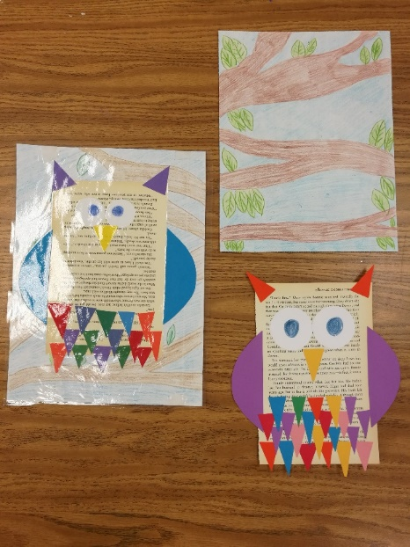  Wise Owl – Materials Needed: book pages, colorful triangles, large white circles, large crescent shapes for wings, drawing paper, blue/green/brown color pencils. Steps for Project: Draw smaller circles inside of the white pre-cut circles and fill them in with a color pencil. Glue these towards the top of a book page for the eyes. Glue two matching triangles to the top corners of the book page for ears. Glue an upside down triangle in between the bottom of the eyes for the beak. Glue the crescent shaped wings to the back of the book pages on either side. Glue rows of upside down triangles starting at the bottom of the book page and working your way up to about a half inch under the beak. While the owl dries use a brown color pencil to draw branches going across the drawing paper and fill them in. Add green leaves. Draw clouds in the remainder of the space and fill in the background with a blue color pencil. | Silly Sally – Materials Needed: Paper plates, color pencils, markers, hole punch, pipe cleaners. Steps for Project: Start by punching several holes around the edge of half of the paper plate. Draw facial features on the paper plate using color pencils and or markers. Wrap each pipe cleaner around a finger or marker to create curls. Wrap pipe cleaner through punched holes and tie around itself to hold in place. | art is for everybody  - K. Powell, Opelousas Sr. High kjb6425@slp.k12.la.us
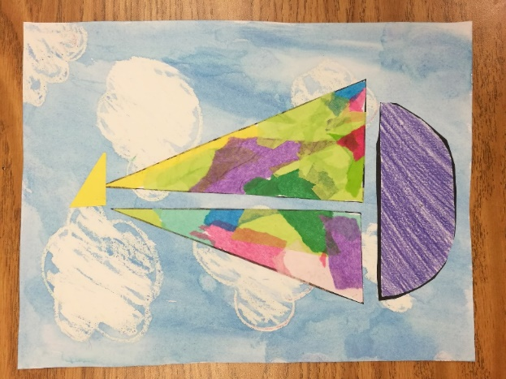  Colorful Sailboat – Materials Needed: watercolor paper, color pencils, white oil crayons, blue water color paint, glue sticks, tissue paper, copies of sails and boat, scissors, paper towels, pencils. Steps for Project: Rip up small pieces of colorful tissue paper and fill in the two pre-drawn triangles. Color the half circle with a color pencil. Let the tissue paper dry and draw clouds with a white oil crayon on the watercolor paper. Paint the entire watercolor paper with blue watercolor paint. Cut out the three shapes once the glue dries. Glue the two triangles and half circle to create a sailboat. Add a pre-cut triangle to the top of the sails. | 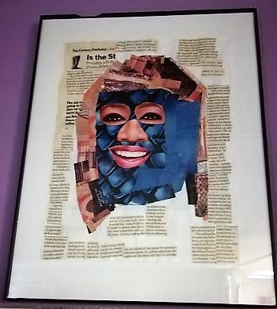  Collage Self Portrait – Materials Needed: Drawing paper, scissors, glue, magazines and or painting paper/paint/paint brushes/cups of water/aprons. Steps for Project: Draw a large oval on a sheet of drawing paper. Cut out pictures of objects that you like in magazines to fill the entire background. Look through magazines (look for like colors, objects, skin tones, etc) to fill the oval in. Cut out two eyes, a nose, a mouth, hair etc to add to the oval to create a face. Another option you may also try is to paint paper and rip it up to fill in the background and face instead of using the magazines. | 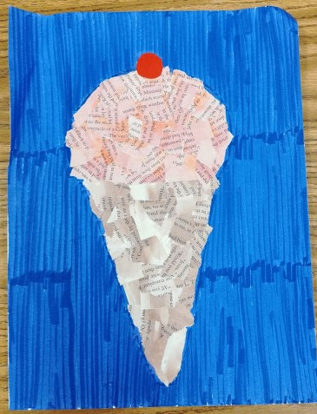  Collage Ice Cream Cone – Materials Needed: Glue, construction paper, watercolor paint, brushes, cups of water, aprons, recycled book pages. Steps for Project: Paint two recycled book pages (1 for the cone & 1 for the ice cream) Set aside to let dry. Draw a small circle, paint it red, cut it out once dry. Once pages are dry, rip them up into smaller pieces. Draw the shape of the cone and scoop of ice cream on a sheet of construction paper. Alternative option for background: Color and decorate a sheet of drawing paper. Use the ripped papers to fill in shape of the cone and ice cream scoop. At red circle to the top.

